Michael Chan

RBE 549

Get Tiny Images:

When writing this function, all that was really needed was to resize the image from a roughly 200x200 picture to a 16x16 image. Then I reshape the 16x16 image into a 256x1 vector. This is essentially the feature vector for the image. You then run this for every single image in the set. So 1500 iterations.

Nearest Neighbors Classify:

For this function, I made the decision to just use the L2 distance as my distance. I took every single feature vector in my test set, and compared it to every single image in my training set. I then sort that matrix to find the smallest distance vector in the matrix. I then take the smallest distance vector and add it to my predicted categories.

Build Vocabulary:

For build vocabulary, for each image I detected SURF features of the image and then extracted HOG features from the top 300 points. I then made the design decision that rather than take all of the detected features, I would take a random permutation of features from each group and then add that to an overall matrix. I do this for each image, and then run k-means clustering on the whole overall matrix. This returns my vocab which is a nxd matrix, which is the number of clusters I wanted by the feature descriptor length.

Bag of Words:

For bag of words, I started off doing the same thing as I did in build vocab. I detected surf features and then extract HOG features around the strongest 300 points. I then compute nearest neighbors for the feature to each of the features of the vocab. This finds the distance of the feature to the centroids found by kmeans. I then find the index of the smallest distance as that will give me the closest centroid the feature is to. I then add that index to a histogram of length vocab. Then I normalize the histogram and append it to the image features.

SVM classfier:

For each category, I compare the category to the training labels using strcmp. This returns a binary representation of matches that I call matchInd. I then use fitclinear on train image feats and matchInd to find the curve that best fits it. Then since fitclinear outputs Beta and Bias, I just input those fields into the equation W\*X+B where W is the Beta and B is the bias. This outputs the confidence that I then append into a scores

|  |  |
| --- | --- |
| Feature + Classifier | Percentage |
| Tiny Images + NN | 20.1% |
| Bag Of Words + NN | 50.3% |
| Bag Of Words + SVM | 45.4% |

**Confusion Matrix for Bag of Words + NN**

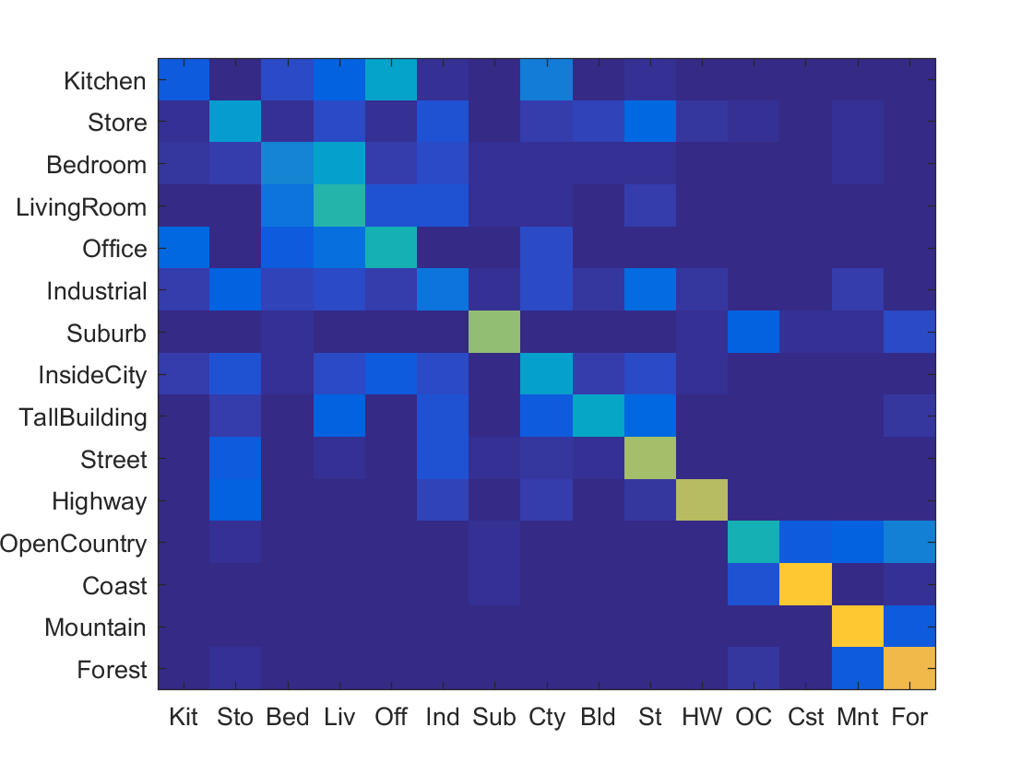

**Table of Classifiers**

|  |  |  |  |  |  |  |  |  |  |
| --- | --- | --- | --- | --- | --- | --- | --- | --- | --- |
| **Category name** | **Accuracy** | **Sample training images** | | **Sample true positives** | | **False positives with true label** | | **False negatives with wrong predicted label** | |
| Kitchen | 0.120 | C:\Users\Girls Who Code\Desktop\RBE549\Assignment 4\code\results_webpage\thumbnails\Kitchen_image_0086.jpg | C:\Users\Girls Who Code\Desktop\RBE549\Assignment 4\code\results_webpage\thumbnails\Kitchen_image_0101.jpg | C:\Users\Girls Who Code\Desktop\RBE549\Assignment 4\code\results_webpage\thumbnails\Kitchen_image_0002.jpg | C:\Users\Girls Who Code\Desktop\RBE549\Assignment 4\code\results_webpage\thumbnails\Kitchen_image_0120.jpg | C:\Users\Girls Who Code\Desktop\RBE549\Assignment 4\code\results_webpage\thumbnails\Office_image_0112.jpg Office | C:\Users\Girls Who Code\Desktop\RBE549\Assignment 4\code\results_webpage\thumbnails\InsideCity_image_0109.jpg InsideCity | C:\Users\Girls Who Code\Desktop\RBE549\Assignment 4\code\results_webpage\thumbnails\Kitchen_image_0071.jpg InsideCity | C:\Users\Girls Who Code\Desktop\RBE549\Assignment 4\code\results_webpage\thumbnails\Kitchen_image_0042.jpg LivingRoom |
| Store | 0.340 | C:\Users\Girls Who Code\Desktop\RBE549\Assignment 4\code\results_webpage\thumbnails\Store_image_0264.jpg | C:\Users\Girls Who Code\Desktop\RBE549\Assignment 4\code\results_webpage\thumbnails\Store_image_0144.jpg | C:\Users\Girls Who Code\Desktop\RBE549\Assignment 4\code\results_webpage\thumbnails\Store_image_0088.jpg | C:\Users\Girls Who Code\Desktop\RBE549\Assignment 4\code\results_webpage\thumbnails\Store_image_0032.jpg | C:\Users\Girls Who Code\Desktop\RBE549\Assignment 4\code\results_webpage\thumbnails\InsideCity_image_0104.jpg InsideCity | C:\Users\Girls Who Code\Desktop\RBE549\Assignment 4\code\results_webpage\thumbnails\Street_image_0010.jpg Street | C:\Users\Girls Who Code\Desktop\RBE549\Assignment 4\code\results_webpage\thumbnails\Store_image_0024.jpg Street | C:\Users\Girls Who Code\Desktop\RBE549\Assignment 4\code\results_webpage\thumbnails\Store_image_0041.jpg Street |
| Bedroom | 0.260 | C:\Users\Girls Who Code\Desktop\RBE549\Assignment 4\code\results_webpage\thumbnails\Bedroom_image_0204.jpg | C:\Users\Girls Who Code\Desktop\RBE549\Assignment 4\code\results_webpage\thumbnails\Bedroom_image_0194.jpg | C:\Users\Girls Who Code\Desktop\RBE549\Assignment 4\code\results_webpage\thumbnails\Bedroom_image_0050.jpg | C:\Users\Girls Who Code\Desktop\RBE549\Assignment 4\code\results_webpage\thumbnails\Bedroom_image_0175.jpg | C:\Users\Girls Who Code\Desktop\RBE549\Assignment 4\code\results_webpage\thumbnails\Kitchen_image_0073.jpg Kitchen | C:\Users\Girls Who Code\Desktop\RBE549\Assignment 4\code\results_webpage\thumbnails\Suburb_image_0148.jpg Suburb | C:\Users\Girls Who Code\Desktop\RBE549\Assignment 4\code\results_webpage\thumbnails\Bedroom_image_0033.jpg Store | C:\Users\Girls Who Code\Desktop\RBE549\Assignment 4\code\results_webpage\thumbnails\Bedroom_image_0128.jpg Industrial |
| LivingRoom | 0.470 | C:\Users\Girls Who Code\Desktop\RBE549\Assignment 4\code\results_webpage\thumbnails\LivingRoom_image_0139.jpg | C:\Users\Girls Who Code\Desktop\RBE549\Assignment 4\code\results_webpage\thumbnails\LivingRoom_image_0244.jpg | C:\Users\Girls Who Code\Desktop\RBE549\Assignment 4\code\results_webpage\thumbnails\LivingRoom_image_0010.jpg | C:\Users\Girls Who Code\Desktop\RBE549\Assignment 4\code\results_webpage\thumbnails\LivingRoom_image_0088.jpg | C:\Users\Girls Who Code\Desktop\RBE549\Assignment 4\code\results_webpage\thumbnails\TallBuilding_image_0116.jpg TallBuilding | C:\Users\Girls Who Code\Desktop\RBE549\Assignment 4\code\results_webpage\thumbnails\Store_image_0021.jpg Store | C:\Users\Girls Who Code\Desktop\RBE549\Assignment 4\code\results_webpage\thumbnails\LivingRoom_image_0040.jpg Industrial | C:\Users\Girls Who Code\Desktop\RBE549\Assignment 4\code\results_webpage\thumbnails\LivingRoom_image_0111.jpg Bedroom |
| Office | 0.450 | C:\Users\Girls Who Code\Desktop\RBE549\Assignment 4\code\results_webpage\thumbnails\Office_image_0039.jpg | C:\Users\Girls Who Code\Desktop\RBE549\Assignment 4\code\results_webpage\thumbnails\Office_image_0086.jpg | C:\Users\Girls Who Code\Desktop\RBE549\Assignment 4\code\results_webpage\thumbnails\Office_image_0009.jpg | C:\Users\Girls Who Code\Desktop\RBE549\Assignment 4\code\results_webpage\thumbnails\Office_image_0134.jpg | C:\Users\Girls Who Code\Desktop\RBE549\Assignment 4\code\results_webpage\thumbnails\InsideCity_image_0051.jpg InsideCity | C:\Users\Girls Who Code\Desktop\RBE549\Assignment 4\code\results_webpage\thumbnails\Industrial_image_0055.jpg Industrial | C:\Users\Girls Who Code\Desktop\RBE549\Assignment 4\code\results_webpage\thumbnails\Office_image_0148.jpg Bedroom | C:\Users\Girls Who Code\Desktop\RBE549\Assignment 4\code\results_webpage\thumbnails\Office_image_0123.jpg Bedroom |
| Industrial | 0.200 | C:\Users\Girls Who Code\Desktop\RBE549\Assignment 4\code\results_webpage\thumbnails\Industrial_image_0048.jpg | C:\Users\Girls Who Code\Desktop\RBE549\Assignment 4\code\results_webpage\thumbnails\Industrial_image_0159.jpg | C:\Users\Girls Who Code\Desktop\RBE549\Assignment 4\code\results_webpage\thumbnails\Industrial_image_0101.jpg | C:\Users\Girls Who Code\Desktop\RBE549\Assignment 4\code\results_webpage\thumbnails\Industrial_image_0118.jpg | C:\Users\Girls Who Code\Desktop\RBE549\Assignment 4\code\results_webpage\thumbnails\Street_image_0070.jpg Street | C:\Users\Girls Who Code\Desktop\RBE549\Assignment 4\code\results_webpage\thumbnails\TallBuilding_image_0013.jpg TallBuilding | C:\Users\Girls Who Code\Desktop\RBE549\Assignment 4\code\results_webpage\thumbnails\Industrial_image_0081.jpg InsideCity | C:\Users\Girls Who Code\Desktop\RBE549\Assignment 4\code\results_webpage\thumbnails\Industrial_image_0075.jpg Suburb |
| Suburb | 0.630 | C:\Users\Girls Who Code\Desktop\RBE549\Assignment 4\code\results_webpage\thumbnails\Suburb_image_0055.jpg | C:\Users\Girls Who Code\Desktop\RBE549\Assignment 4\code\results_webpage\thumbnails\Suburb_image_0086.jpg | C:\Users\Girls Who Code\Desktop\RBE549\Assignment 4\code\results_webpage\thumbnails\Suburb_image_0005.jpg | C:\Users\Girls Who Code\Desktop\RBE549\Assignment 4\code\results_webpage\thumbnails\Suburb_image_0004.jpg | C:\Users\Girls Who Code\Desktop\RBE549\Assignment 4\code\results_webpage\thumbnails\Street_image_0141.jpg Street | C:\Users\Girls Who Code\Desktop\RBE549\Assignment 4\code\results_webpage\thumbnails\Bedroom_image_0087.jpg Bedroom | C:\Users\Girls Who Code\Desktop\RBE549\Assignment 4\code\results_webpage\thumbnails\Suburb_image_0154.jpg OpenCountry | C:\Users\Girls Who Code\Desktop\RBE549\Assignment 4\code\results_webpage\thumbnails\Suburb_image_0037.jpg OpenCountry |
| InsideCity | 0.350 | C:\Users\Girls Who Code\Desktop\RBE549\Assignment 4\code\results_webpage\thumbnails\InsideCity_image_0182.jpg | C:\Users\Girls Who Code\Desktop\RBE549\Assignment 4\code\results_webpage\thumbnails\InsideCity_image_0115.jpg | C:\Users\Girls Who Code\Desktop\RBE549\Assignment 4\code\results_webpage\thumbnails\InsideCity_image_0129.jpg | C:\Users\Girls Who Code\Desktop\RBE549\Assignment 4\code\results_webpage\thumbnails\InsideCity_image_0060.jpg | C:\Users\Girls Who Code\Desktop\RBE549\Assignment 4\code\results_webpage\thumbnails\Office_image_0164.jpg Office | C:\Users\Girls Who Code\Desktop\RBE549\Assignment 4\code\results_webpage\thumbnails\Highway_image_0135.jpg Highway | C:\Users\Girls Who Code\Desktop\RBE549\Assignment 4\code\results_webpage\thumbnails\InsideCity_image_0012.jpg Highway | C:\Users\Girls Who Code\Desktop\RBE549\Assignment 4\code\results_webpage\thumbnails\InsideCity_image_0079.jpg Industrial |
| TallBuilding | 0.390 | C:\Users\Girls Who Code\Desktop\RBE549\Assignment 4\code\results_webpage\thumbnails\TallBuilding_image_0012.jpg | C:\Users\Girls Who Code\Desktop\RBE549\Assignment 4\code\results_webpage\thumbnails\TallBuilding_image_0076.jpg | C:\Users\Girls Who Code\Desktop\RBE549\Assignment 4\code\results_webpage\thumbnails\TallBuilding_image_0004.jpg | C:\Users\Girls Who Code\Desktop\RBE549\Assignment 4\code\results_webpage\thumbnails\TallBuilding_image_0024.jpg | C:\Users\Girls Who Code\Desktop\RBE549\Assignment 4\code\results_webpage\thumbnails\Store_image_0014.jpg Store | C:\Users\Girls Who Code\Desktop\RBE549\Assignment 4\code\results_webpage\thumbnails\Store_image_0087.jpg Store | C:\Users\Girls Who Code\Desktop\RBE549\Assignment 4\code\results_webpage\thumbnails\TallBuilding_image_0016.jpg Industrial | C:\Users\Girls Who Code\Desktop\RBE549\Assignment 4\code\results_webpage\thumbnails\TallBuilding_image_0116.jpg LivingRoom |
| Street | 0.670 | C:\Users\Girls Who Code\Desktop\RBE549\Assignment 4\code\results_webpage\thumbnails\Street_image_0173.jpg | C:\Users\Girls Who Code\Desktop\RBE549\Assignment 4\code\results_webpage\thumbnails\Street_image_0059.jpg | C:\Users\Girls Who Code\Desktop\RBE549\Assignment 4\code\results_webpage\thumbnails\Street_image_0119.jpg | C:\Users\Girls Who Code\Desktop\RBE549\Assignment 4\code\results_webpage\thumbnails\Street_image_0014.jpg | C:\Users\Girls Who Code\Desktop\RBE549\Assignment 4\code\results_webpage\thumbnails\LivingRoom_image_0142.jpg LivingRoom | C:\Users\Girls Who Code\Desktop\RBE549\Assignment 4\code\results_webpage\thumbnails\Industrial_image_0061.jpg Industrial | C:\Users\Girls Who Code\Desktop\RBE549\Assignment 4\code\results_webpage\thumbnails\Street_image_0070.jpg Industrial | C:\Users\Girls Who Code\Desktop\RBE549\Assignment 4\code\results_webpage\thumbnails\Street_image_0053.jpg InsideCity |
| Highway | 0.690 | C:\Users\Girls Who Code\Desktop\RBE549\Assignment 4\code\results_webpage\thumbnails\Highway_image_0138.jpg | C:\Users\Girls Who Code\Desktop\RBE549\Assignment 4\code\results_webpage\thumbnails\Highway_image_0254.jpg | C:\Users\Girls Who Code\Desktop\RBE549\Assignment 4\code\results_webpage\thumbnails\Highway_image_0100.jpg | C:\Users\Girls Who Code\Desktop\RBE549\Assignment 4\code\results_webpage\thumbnails\Highway_image_0104.jpg | C:\Users\Girls Who Code\Desktop\RBE549\Assignment 4\code\results_webpage\thumbnails\Industrial_image_0006.jpg Industrial | C:\Users\Girls Who Code\Desktop\RBE549\Assignment 4\code\results_webpage\thumbnails\InsideCity_image_0035.jpg InsideCity | C:\Users\Girls Who Code\Desktop\RBE549\Assignment 4\code\results_webpage\thumbnails\Highway_image_0002.jpg Street | C:\Users\Girls Who Code\Desktop\RBE549\Assignment 4\code\results_webpage\thumbnails\Highway_image_0155.jpg Store |
| OpenCountry | 0.450 | C:\Users\Girls Who Code\Desktop\RBE549\Assignment 4\code\results_webpage\thumbnails\OpenCountry_image_0390.jpg | C:\Users\Girls Who Code\Desktop\RBE549\Assignment 4\code\results_webpage\thumbnails\OpenCountry_image_0272.jpg | C:\Users\Girls Who Code\Desktop\RBE549\Assignment 4\code\results_webpage\thumbnails\OpenCountry_image_0079.jpg | C:\Users\Girls Who Code\Desktop\RBE549\Assignment 4\code\results_webpage\thumbnails\OpenCountry_image_0117.jpg | C:\Users\Girls Who Code\Desktop\RBE549\Assignment 4\code\results_webpage\thumbnails\Forest_image_0102.jpg Forest | C:\Users\Girls Who Code\Desktop\RBE549\Assignment 4\code\results_webpage\thumbnails\Suburb_image_0024.jpg Suburb | C:\Users\Girls Who Code\Desktop\RBE549\Assignment 4\code\results_webpage\thumbnails\OpenCountry_image_0021.jpg Mountain | C:\Users\Girls Who Code\Desktop\RBE549\Assignment 4\code\results_webpage\thumbnails\OpenCountry_image_0064.jpg Mountain |
| Coast | 0.860 | C:\Users\Girls Who Code\Desktop\RBE549\Assignment 4\code\results_webpage\thumbnails\Coast_image_0283.jpg | C:\Users\Girls Who Code\Desktop\RBE549\Assignment 4\code\results_webpage\thumbnails\Coast_image_0015.jpg | C:\Users\Girls Who Code\Desktop\RBE549\Assignment 4\code\results_webpage\thumbnails\Coast_image_0121.jpg | C:\Users\Girls Who Code\Desktop\RBE549\Assignment 4\code\results_webpage\thumbnails\Coast_image_0044.jpg | C:\Users\Girls Who Code\Desktop\RBE549\Assignment 4\code\results_webpage\thumbnails\OpenCountry_image_0084.jpg OpenCountry | C:\Users\Girls Who Code\Desktop\RBE549\Assignment 4\code\results_webpage\thumbnails\Forest_image_0105.jpg Forest | C:\Users\Girls Who Code\Desktop\RBE549\Assignment 4\code\results_webpage\thumbnails\Coast_image_0005.jpg OpenCountry | C:\Users\Girls Who Code\Desktop\RBE549\Assignment 4\code\results_webpage\thumbnails\Coast_image_0036.jpg Forest |
| Mountain | 0.870 | C:\Users\Girls Who Code\Desktop\RBE549\Assignment 4\code\results_webpage\thumbnails\Mountain_image_0355.jpg | C:\Users\Girls Who Code\Desktop\RBE549\Assignment 4\code\results_webpage\thumbnails\Mountain_image_0226.jpg | C:\Users\Girls Who Code\Desktop\RBE549\Assignment 4\code\results_webpage\thumbnails\Mountain_image_0031.jpg | C:\Users\Girls Who Code\Desktop\RBE549\Assignment 4\code\results_webpage\thumbnails\Mountain_image_0082.jpg | C:\Users\Girls Who Code\Desktop\RBE549\Assignment 4\code\results_webpage\thumbnails\Store_image_0017.jpg Store | C:\Users\Girls Who Code\Desktop\RBE549\Assignment 4\code\results_webpage\thumbnails\Industrial_image_0016.jpg Industrial | C:\Users\Girls Who Code\Desktop\RBE549\Assignment 4\code\results_webpage\thumbnails\Mountain_image_0013.jpg Forest | C:\Users\Girls Who Code\Desktop\RBE549\Assignment 4\code\results_webpage\thumbnails\Mountain_image_0105.jpg Forest |
| Forest | 0.800 | C:\Users\Girls Who Code\Desktop\RBE549\Assignment 4\code\results_webpage\thumbnails\Forest_image_0300.jpg | C:\Users\Girls Who Code\Desktop\RBE549\Assignment 4\code\results_webpage\thumbnails\Forest_image_0193.jpg | C:\Users\Girls Who Code\Desktop\RBE549\Assignment 4\code\results_webpage\thumbnails\Forest_image_0070.jpg | C:\Users\Girls Who Code\Desktop\RBE549\Assignment 4\code\results_webpage\thumbnails\Forest_image_0093.jpg | C:\Users\Girls Who Code\Desktop\RBE549\Assignment 4\code\results_webpage\thumbnails\Bedroom_image_0003.jpg Bedroom | C:\Users\Girls Who Code\Desktop\RBE549\Assignment 4\code\results_webpage\thumbnails\Suburb_image_0021.jpg Suburb | C:\Users\Girls Who Code\Desktop\RBE549\Assignment 4\code\results_webpage\thumbnails\Forest_image_0011.jpg Mountain | C:\Users\Girls Who Code\Desktop\RBE549\Assignment 4\code\results_webpage\thumbnails\Forest_image_0059.jpg Mountain |
| **Category name** | **Accuracy** | **Sample training images** | | **Sample true positives** | | **False positives with true label** | | **False negatives with wrong predicted label** | |